Terms & Conditions | HSSC Online

Harrow School Short Courses is a trading name of Harrow School Enterprises Limited registered in England, company number 1617359. Harrow School Enterprises Ltd is a wholly owned subsidiary of Harrow School (‘The School’), registered charity number 310033.

IT REQUIREMENTS

HSSC Online uses a virtual classroom and a virtual online campus to deliver our courses. You can access our virtual school with your computer, laptop, or tablet. We do not recommend attending our online classes via a smartphone because of the smaller screen size. Before you book a course with HSSC Online, you should ensure that your system meets the minimum requirements to use our virtual school effectively:

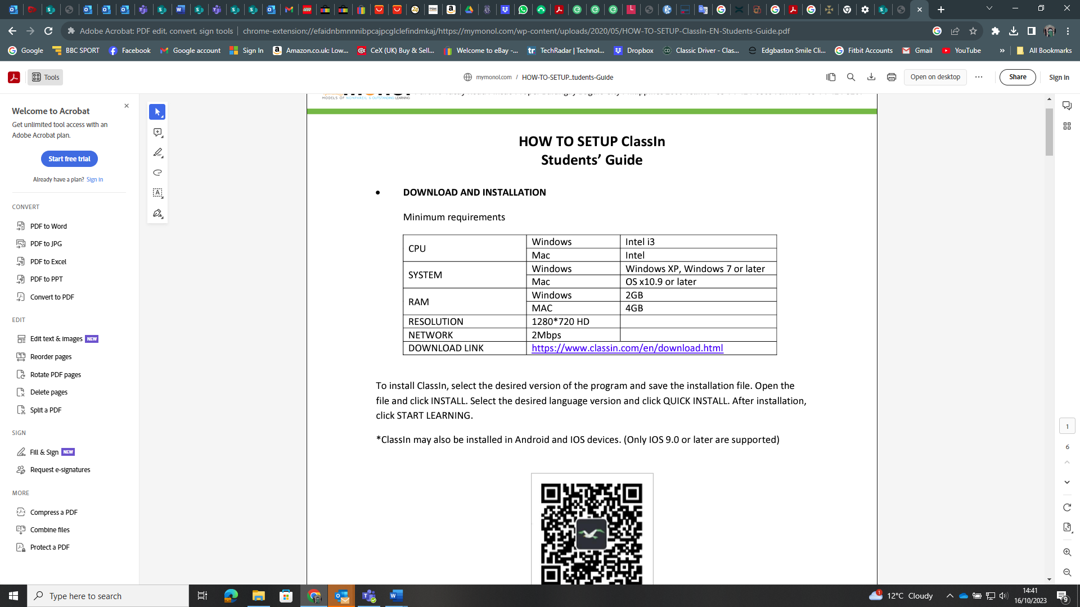

Download Link: https://www.classin.com/download/

We recommend using headphones or earphones for the lessons to reduce feedback noise. You will also need a webcam and microphone.

ENROLMENT
- When you book a course with HSSC Online, you can request a lesson time and teacher. We confirm these lesson details by email normally within 2 or 3 working days and no later than 10 days after receiving a booking request. Full payment of all course fees is required within 2 working days of our email to secure a place on the course. A booking is not a guarantee of enrolment until we have confirmed course details by email, and you have paid the course fees.
- If we cannot offer the time and/or teacher that you requested when you booked, we will email you to arrange an alternative time and/or teacher. If we cannot arrange an alternative which you are happy with, we will cancel the booking request.
- When a course booking has been confirmed, students will normally complete all lessons in their course at the arranged time/s with the same teacher. All lessons in the course need to be completed before the course end date.
  - For twenty-lesson programmes, the course end date is normally four/five months after the first lesson.
  - For ten-lesson Online lesson programmes, the course end date is normally three/four months after the first lesson.
  - For a two-lesson trial, the course end date is normally one month after the first lesson.

- Course end dates can be subject to change or extension depending on circumstances. All changes are negotiated with the HSSC Online Academic Principal.
- After their enrolment has been confirmed, students are sent a username and password and details of how to access the HSSC Online Campus and their virtual classroom.
- Students must not share their username and password with anyone. If someone discovers the password, please contact HSSC Online and we will reset it.
- Students have access to the HSSC Online Campus from before their first lesson through to four months on 20 lesson courses, three months on 10 lesson courses and one month for two lesson trial courses after the course end date. Access is available 24 hours, 7 days a week. If a student cannot access the HSSC Online Campus for a period of time because of a technical problem with our software, their access will be extended after their course end date for an equivalent period of time.
- If a teacher becomes unavailable to complete a course of study, we will contact you to arrange an alternative teacher. If we cannot arrange an alternative you are happy with, we will return course fees for the remaining part of the course.
- If you provide incorrect information or misinformation in an application to HSSC Online, we may cancel the course without refunding the course fees.
- Please note, enrolments cannot be transferred to an alternative student.

ENROLMENT AMENDMENTS

- After a student has enrolled on a HSSC Online course, it is not possible to change their name or the type of course they have enrolled on.
- Other amendments such as changes to the course start date and lesson time may be possible depending on the teacher’s availability. Please contact us with any requests at least three working days before the start of the course.
- After a course has started, you may change the regular lesson time providing you agree this with the teacher at least 48 hours before the next lesson in the course and you can find an alternative time that suits the student and teacher.
- Students cannot normally change teachers during their course unless their original teacher becomes unavailable.

CANCELLATION

- Please contact us immediately if you need to cancel a course.
- If you email to tell us you wish to cancel a course more than one week before the start of the course, we will refund the course fees minus a £50 administrative fee.
- If you email to tell us you wish to cancel a course less than one week before the start of the course, we will refund 50% of your course fees.
- We will not refund course fees if you cancel a course after the start of that course.

ATTENDANCE POLICY

- You can postpone or rearrange some of the lessons in a course if you inform the teacher at least 48 hours before the lesson is due to begin and all lessons are completed by the course end date. The teacher may postpone or rearrange some of the lessons in the course if they inform you at least 48 hours before the lesson is due to begin and all lessons are completed by the course end date.

- For twenty-lesson programmes, up to three lessons can be changed by the student and three lessons changed by the teacher.
- For ten-lesson programmes, up to two lessons can be changed by the student and two lessons changed by the teacher.
- For a two-lesson trial, one lesson can be changed if agreed by all parties in advance.
- If you inform the teacher that you cannot attend a lesson less than 48 hours before the lesson is due to begin, the teacher will cancel that lesson and we will not normally offer a replacement lesson.
- If a teacher needs to cancel a lesson less than 48 hours before the lesson is due to begin, s/he will contact you to arrange an alternative time for the lesson. If s/he cannot find an alternative time, the lesson will be postponed to the following week and the course end date extended by a week.
- If a student or teacher cannot access the virtual classroom because of a technical problem with the virtual classroom software, the lesson will be postponed to the following week and the course end date extended by a week.
- If a student cannot access the virtual classroom because of a technical problem with their IT or internet connection, the lesson will be cancelled and we will not offer a replacement lesson.
- If a student can access the virtual classroom but has an IT problem such as their webcam freezing or microphone not working, if possible, the teacher will continue with the lesson and adapt the activities to allow as much participation as possible. For example, if the microphone is not working, communication will be through the chat box.
- If a student is late to their lesson, they will lose the lesson time they have missed. If they are more than twenty minutes late to their lesson and they do not contact their teacher to tell them when they will join the lesson, their teacher will log out of the classroom and cancel the lesson. The student will not be offered a replacement lesson.
- If a teacher is late to a lesson and s/he has not contacted you to tell you when s/he will join the lesson, please email the teacher and hssconline@harrowschool.org.uk and tell us you are waiting for the lesson to start. If the lesson starts late because of the teacher, s/he will extend the lesson or arrange to make up the missed time at another time that suits you both.

RE-ENROLLMENT

- If you wish to reenrol with HSSC Online, you will have the option of continuing to study with the same teacher if they are available or changing the teacher and/or lesson time. You can reenrol at any time but should complete reenrolment at least two weeks before the end of a course if you want us to reserve the same time and teacher, because this will ensure another client cannot reserve that teacher at that time.

LIABILITY

- Harrow School Short Courses and The School have public liability insurance. Any liability of Harrow School Short Courses or of The School to the student or parent or guardian, in respect of which Harrow School Short Courses or The School has insurance cover, shall be limited to the amount of such cover and any such liability in respect of which Harrow School Short Courses or The School does not have insurance cover shall be limited to the aggregate amount of fees paid in respect of the student. Nothing in these terms and conditions, however, shall operate to exclude any liability of Harrow School Short Courses or The School for personal injury or death caused by negligence of Harrow School Short Courses or The School or our respective servants and agents.
- It is a condition of the contract between Harrow School Short Courses, The School and the student or his or her parent or guardian, that Harrow School Short Courses and The School shall not, in any way, be liable to the student or the parent or guardian in the event that any service contracted to be supplied by Harrow School Short Courses or The School becomes impossible to supply due to reasons outside our control.

LESSON VIDEOS AND OUR PRIVACY POLICY

- All lessons are recorded. The recordings can be used by the student to view back lesson material.
- After each lesson, the student can access the recording via a link on their virtual classroom dashboard. Recordings are protected and can only be viewed by entering the student’s password.
- Students can share these recordings with members of their immediate family. Recordings must not be shared outside the student’s immediate family or to the public domain, e.g., YouTube.
- We sometimes use screenshots or video clips of lessons in HSSC Online promotional material. We only use screenshots or video clips showing the identifiable image of a student with prior permission from the student and their parents.
- Students and/or their parent or guardian are asked to complete a course evaluation form at the end of the course. We sometimes use comments from these evaluations in HSSC Online promotional material with prior permission from the person who completes the evaluation.
- For full details of how we collect, store, and process your data, please see the Harrow School Data Protection Policy.

COMPLAINTS PROCEDURE

We are sure students will be very happy and learn a lot on their courses. However, please tell us at once if you have a problem or are not happy with your course. We will always try to help you.

- Speak to your Online Teacher if you are not happy with your HSSC Online course.
- If you are still not happy or do not want to talk to your teacher, contact us at: hssconline@harrowschool.org.uk or by phone on: +44 (0) 208 426 4638.
- If you are still not happy, contact the Interim Chief Operating Officer at: billingej@harrowschool.org.uk
- If you are still not happy, contact English UK. Write to: English UK, 219 St John Street, London, EC1V 4LY, or email info@englishuk.com.

